Field Day 2016: the perfect weekend for showcasing what we do at MF/LF/VLF
By John Langridge July 4, 2016 – Posted in: 630 Meter General Topics, 630 Meters
Its been about a week since Field Day ended and I feel like I have received the bulk of the reports that will come in. I have reached out to a few groups for photos and those will be added when and if they are received. If you requested a QSL card for my station, those have all been mailed. Details of my activities, as well as the activities of several other active stations are included in the June 26, 2016 daily report, which can be found here. The remaining reports are listed below:
Neil, W0YSE/7 / WG2XSV, went the extra mile by getting out into the local community and actively demonstrated the power of medium wave radio to many operators that might not have ever gotten to experience it otherwise. Neil offers these details:
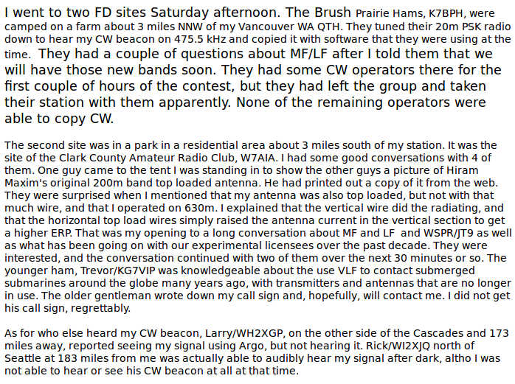
Neil also noted a report from Toby, VE7CNF, indicating that WG2XSV was S4 at RST 559 on Sunday morning at 0800z.
Also active during the weekend was our first VLF station to participate in the Field Day outreach event. While this spectrum generally requires more specialized equipment for reception (receive converters for most stations), a number of low band stalwarts received Ron, NI7J / WH2XND, on 70 kHz WSPR during the weekend. While a number of reports have since been received from across the country, focus is placed on the reports observed during the field day weekend.
Ron reports two local stations receiving his signal, Mike, NR5O / WH2XAR, and Ward, K7PO / WH2XXP. Mike provided the following WSPR console showing his receptions:
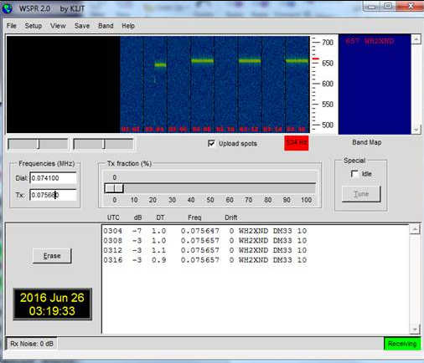
WH2XND on 70 kHz, as reported by WH2XAR

Ron also notes long haul reports from Larry, W7IUV / WH2XGP, in Washington state, who provided the dataset below. Note that the data indicates 137 kHz but it really is 70 kHz. There were some early frequency compatibility problems with WSPR resulting in the wrong band being reported:
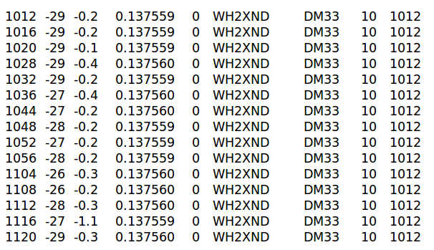
So that’s what I have at the moment. If you have pictures, stories or details about your activity during field day related to 630-meters, 2200-meters or lower, please send that information. I hope to add some pictures and video of my setup that was used during site visits. Sadly I had two cameras with me and neither one made it out of the car. That happens when you are on the road as a “one man sideshow”.
Thanks to all that reported and all that participated! See you next year!

